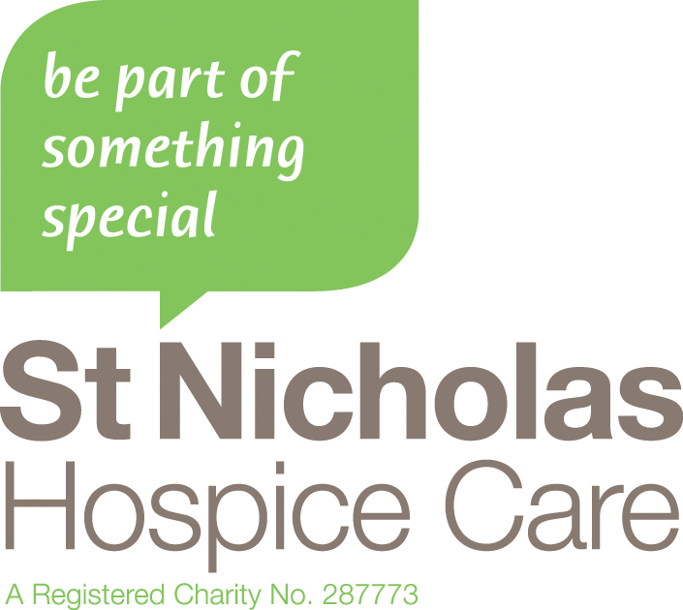

ST NICHOLAS HOSPICE CARE

VOLUNTEER ROLE DESCRIPTION

Role: Creative / Art /Craft Volunteer

Reports to: ILT

Frequency: Once a week (Tuesday)

Base: Haverhill and Bury St Edmunds
___________________________________________________________________

Role Purpose

- Facilitate creative opportunities for patients in Day Therapy

Responsibilities

- Provide a safe and secure environment within which patients are able to explore creative activities. Examples of these activities could be:

    - Painting and sketching
    - Silk painting
    - Clay work
    - Mosaics
    - Jewellery making in using various types of materials including polymer clay
    - Felt making
    - Knitting and crochet
    - Sewing

Person Specification

- General Art and Craft skills and a willingness to expand these if necessary
- An understanding of patient requirement and limitations
- A flexible and adaptable approach to the nature of the work
- Caring and responsible attitude towards patients and staff
- Commitment to see projects with patients through
- Ability to communcate well at all levels

General

- Ensure that all within the team have a grasp of the Hospice’s structure, values and purpose and have opportunities for involvement in its further development.

- Ensure the maintenance of confidentiality in respect of staff, volunteer and client records and all privileged information relating to the services of the Charity, its patients, staff and volunteers and particularly of the area for which directly responsible.

- Promote and foster the Hospice’s reputation and standing within the community and with private, statutory and voluntary sector agencies and organisations.

- Undertake any other duties which may be reasonably required.

- Volunteers are required to attend mandatory training sessions i.e. information governance, infection prevention etc.

Notes

The managerial and clinical philosophy of the Hospice is based on a multi-disciplinary approach. Staff and Volunteers regardless of grade or discipline, are required to participate in this concept. The role of volunteers is integral with the work of St Nicholas and paid staff are required to underpin this in their attitude and actions.

All staff and volunteers must be sympathetic to and able to project the philosophy and concept of hospice care.

The Hospice has in place provision for staff and volunteer support. Staff and volunteers are expected to exercise responsibility in accessing whatever forms of support might be appropriate for them to ensure that they are able to offer the professional care for which they are employed.

An extract from the summary of the Health & Safety at Work Act 1979 states:-

"Employees and volunteers at Work: It is the duty of every employee and volunteer while at work to carry out their work in a manner which is safe and free from risk to the health of himself/herself and other persons who may be affected by his/her acts or omissions. It is an employee's duty to assist and co-operate with his/her employer in complying with any relevant statutory regulations imposed on his/her employer".

St Nicholas Hospice Care is very much a community and all members of staff and volunteers are encouraged to support the various social and fundraising events which are part of its day to day life.

This Role Description may change and the duties listed are not exhaustive, but such change will only be made following consultation between the (relevant) "Manager" and the Volunteer.

