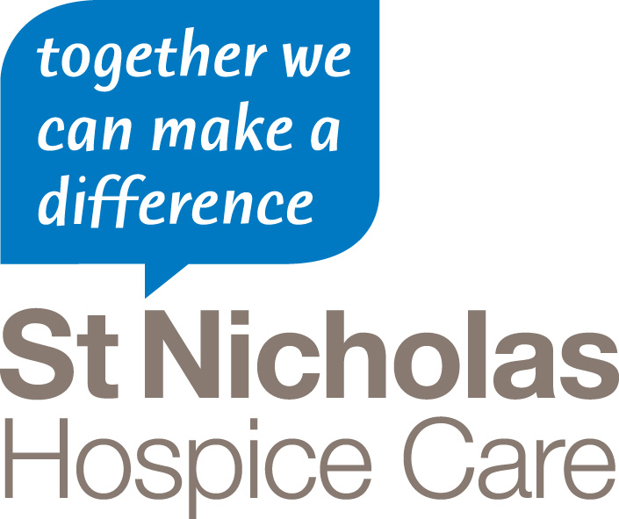
PRESS RELEASE
For immediate release
27 April 2015

Work under way at Hospice’s Garden of Life
Landscapers have started work on a £50,000 garden which will be open to the whole community when it is finished.
The Garden of Life, at St Nicholas Hospice Care’s Burton Centre, in Camps Road, will eventually be a tranquil and accessible space, for use by patients, families and members of the public.
On Thursday, members of the Garden of Life Working Group – which has been meeting regularly since January to help finalise the garden’s design – met for a progress update on site.
The group was show how the garden has been cleared ready for raised beds and pathways to be installed, while the old fence has also been removed ready for the installation of a new fence.
Moira Welham, St Nicholas Hospice Care Head of Community Partnership, said it was hoped the garden would be finished by the end of May, with a grand opening held shortly afterwards.
The garden has been funded by the Big Lottery Fund, after the Hospice won the televised People’s Millions appeal in November.
PICTURE CAPTIONS:
Members of the Garden of Life Working Group see how the Garden of Life has changed, since landscapers moved on to the site.
- Ends -
For more information, please contact Camille Berriman, Press and PR Officer, on 01284 715580 or email camille.berriman@stnh.org.uk

Notes to Editor:

- St Nicholas Hospice Care is a local charity which looks after people with long-term and life-threatening illnesses in their own homes or wherever they need us.
- We help people with illnesses – not just cancer – including Motor Neurone Disease, Parkinson’s, heart failure, MS and lung disease.
- We offer physiotherapy and occupational therapy – to help make everyday living easier and improve quality of life - in people’s own homes, the main Hospice or at our Burton Centre outreach centre, in Haverhill.
- We are there for people’s emotional needs as well as medical needs. Emotional support and counselling can be offered in people’s own homes.
- As a registered charity we have to raise £11,000 every day through the generosity of the local community. We need every penny.
- St Nicholas Hospice Care provides care and support throughout West Suffolk and Thetford.
- More information is available from www.stnicholashospicecare.org.uk

